Afternoon Meeting discussion ideas/question of the day
Looking at the poster below, 100 Positive Mindset Phrases for Kids, the meeting leader can have students say a phrase together, and then students can take turns expressing what the phrase or quote means to them. There are also gratitude and self-esteem conversation prompts included after the poster.
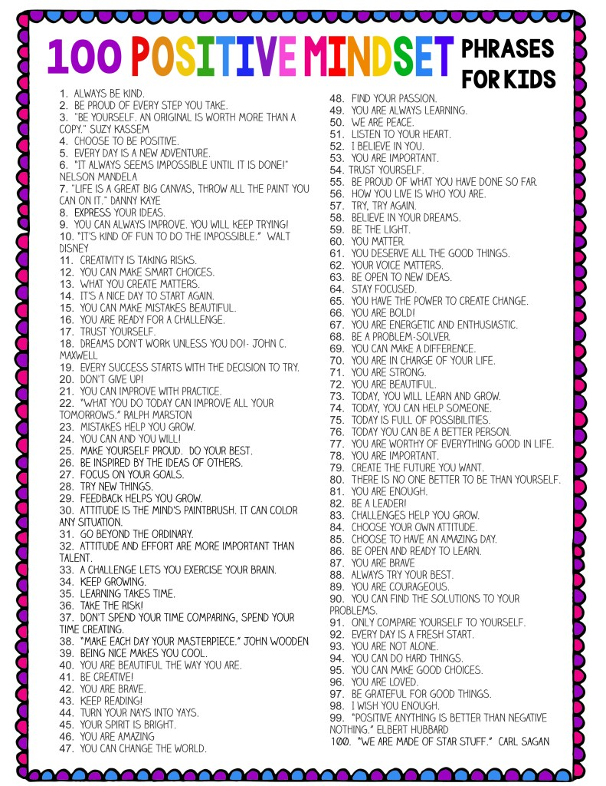

Gratitude conversation prompts
- What was the best thing that happened today?
- Who makes you feel loved and why?
- Name something that makes you happy.
- What is your favorite outdoor activity?
- Name someone that helps you.
- What is your favorite thing to do on the weekend?
- Name something that you are grateful to have.
- What do you like to do with your family and why?
- Name someone nice to you.
- Where is your favorite place to go?
- Name someone that makes you smile.
- Who is your best friend and why?
- What do you like most about school or your job?
- What do you like most about your favorite subject?
- Who was the last person to give you something?
- What is the best gift that you have ever received?
- Name the best thing that has ever happened to you.
- What is your favorite game or sport, and why?
- Where is your favorite place to play or relax?
- What do you like most about your family?
- Name an animal that you feel thankful for.
- What is your favorite thing to do at home?
- Name a person that you love and why.
- What is your favorite hobby, and why?
- Who do you like to spend time with?
- Name someone that you feel grateful for.
- What is your favorite food and why?
- Name an activity that makes your heart sing.
- Describe something that you like about yourself.
- Name something that makes you laugh.
Self Esteem conversation prompts
1. What is your greatest talent?
2. What is the best compliment you’ve ever received?
3. How do your parents encourage you to be more confident?
4. What is a unique quality you have that makes you special.
5. What are five things that define who you are, listing them as “I am ____,” statements. Take a few minutes to think about each one. Which quality feels the best?
6. When is a time when you did something you were afraid to try. How did you feel afterward?
7. When you’re feeling confident, what emotions do you experience?
8. Who is a person you admire. What qualities do you have in common with this person?
9. What is your favorite thing to do? How do you feel when you work on this activity?

10. What does it feel like when someone recognizes something you worked hard to do?
11. What makes you feel like a strong person?
12. What do you do when you see a classmate struggling with something?
13. Of the people in your life, who makes you feel the most confident?
14. Name three qualities you love about yourself.
15. How do you think other people see you?
16. What is self esteem?
17. Why is it important to have high self esteem?
18. How do you know when you’ve succeeded at something?
19. Describe the feeling of confidence.
20. What kinds of things hurt self esteem? How can you discourage these activities?
21. What is your greatest strength?
22. What is the greatest feeling you’ve ever had?
23. Why is it important to congratulate people who do well?
24. What your greatest success?
25. What do you see when you look in the mirror?
26. What does it mean to have confidence?
27. How do you think confidence relates to happiness?
28. How do you feel when you earn good grades?
29. What is your favorite physical feature?
30. What is your favorite intellectual quality?
31. When you want to feel more confident, what do you do?
32. What is your biggest goal? How will you achieve it?
33. When was a time when you helped another person. How did you feel?
34. What makes you happy?
35. Make a list of ten things you’re good at doing. How do these things make you unique?
36. How can you help other people feel more confident?
37. How do you feel when you journal regularly?
38. What is it like to try something new?
39. Do you ever have trouble making decisions? How can you work to make choices more quickly and with more confidence?
40. What are three things that make you happy. How can you spend more time on these things each day?
41. What is the bravest thing you’ve ever done?
42. Why is it important to have high self-esteem?
43. Think of something that you would like to do better. How can you work to improve?
44. How do you feel when someone gives you a compliment?
45. What types of things make you feel confident?
46. Why is it important to spend time with people who appreciate your best qualities?
47. How do positive thoughts promote confidence?
48. What is something you have done well recently?
49. When was a time when you made a great choice.
50. Do you spend time worrying about what other people think? How does this feel?
51. When do you feel proud of yourself?
52. When was a time when you struggled with something new. What did you do to improve?

